A Guide to Successful Blogging
5jw2013.knowleparkblogs.net
Mr James Walker (@MrWalkerKPPS) from Knowle Park Primary School, Bristol
World Map:
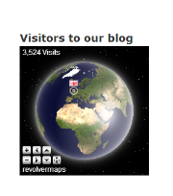
Children are desperate to see how many visitors have been to the blog – this world map widget is fantastic (www.revolvermaps.com) as it shows who is currently on the blog with little flags and dots. The children love seeing that someone else is looking right now!

Flag Counter:
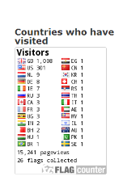
Linked into the world map is the flag counter (www.flagcounter.com) which keeps a record of which countries have visited your blog. Children get a real kick out of spotting a new country on their counter and then learning something about it – especially if they have never heard of it before.

Own log ins:
Really important to make it individual for the children – a way of doing this is for them to have their own log ins so that everything they post automatically has their name on.

Tabs:
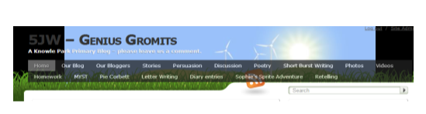
When you have been blogging for a while you might see that the children and parents are finding it hard to get to their posts. You can organise all of the posts into tabs at the top of the page so that they can go straight to all of their own posts by clicking on say “Jamie”. Also you can organise the writing into genres or have a tab for photos/videos etc. Children really like this as they can quickly find say their retelling video from last week.

Tagging:
Make sure that the children tag all their posts with their name and then some key words about their posts for example if they are doing a report about the zoo they might tag: zoo, animals, trip, Jeffrey, report.
This helps them locate their posts on the blog but, more importantly, it helps people searching on google to come to the blog. The more tags your children do, the higher up the google search the blog will go.

Tag cloud:
If the children get into the habit of tagging their work, then keywords will start getting bigger and bigger on the tag cloud. They compete with whose name is the biggest of what topic is the most written about.
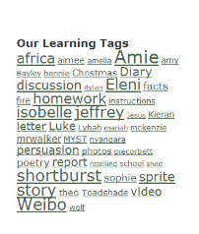
Twitter:
Teachers need to join twitter (if only for school) – this is a great way to get the bog out there, or signpost people to certain blog posts or find other school’s blogs to link up with. If you get someone important to retweet your blog address (Pie, Deputy Mitchell) your views will spike.

Photos and videos:
Instead of taking hours to uploads photos from trips onto the school website or making displays, why not use animoto.com to make photo slideshows for parents to look at and then comment with their thanks.
Vimeo.com is great for uploading videos of children retelling, performances, drama etc which you can then tweet out for the world to see and comment on.

Safeguarding:
Letters to parents – children should already have permission to have their images used on school website etc. Just make sure that you don’t put the child’s full name next to their photograph. All work and comments are read and published by the teacher first.

Leaving comments / publishing work:
Vital (at least to begin with) that you get the children’s interest. Important to publish the children’s work / comments as soon as possible. You can get a wordpress app on your phone so you can do it remotely. The more comments you leave as a teacher, the better until the blog starts having a life of its own. If you don’t get excited about it and make it important, then the children won’t.
Showcase blog in class:
Really important to show/ read out great posts with the whole class or year group. Also highlight when the blog has had a new country added or a comment from someone different/important. There has to be a link between the virtual and the physical classroom so the children’s writing on the blog is given value.
Blogger/ Blog of the week:
In our celebration assembly, we have a blog or blogger of the week who is awarded a trophy which they keep for the week and their work is shown in assembly. Many children and teachers then go and comment on their work.

WORKING BLOGGING INTO LITERACY AND TALK4WRITING
Unfolding narrative:
Especially in talk for writing, having posts suddenly arriving on the blog is really exciting for the children and brings units alive. A surprise post from Zigwoo the friendly alien, the Queen, David Cameron, your headteacher, an African tribesman. etc can be great ways of engaging the children. Setting up discussion/ debates on the blog is a great idea with the children leaving their views as comments. Parents, teachers and new visitors to your blog can make the discussions real.
Homework:
Obviously, it is a great way of getting children to do extra work around the writing unit you are doing. Setting compulsory work on the blog is tricky with those children who may not have internet access at home so it makes more sense to have it as an option for extra homework.
Drafting:
In the planning stage of your unit, allow children to go and ‘have a go’ on the blog. Leave a comment with advice and print out the writing or have an Ipad for the children to then use when they are writing their work in class. You’ll see a massive improvement in writing when they have had an opportunity to do a first draft.
Publishing:
This can apply to either a class session or at home. There are different ways to do it so here are a few suggestions: print blogs and stick into books (great evidence of independent writing); make a blogging display, or signpost parents to blogs on the school website or newsletter.
Impact:
It may not work for every child in every class. In my experience, it has the biggest impact on some of the more vulnerable / under-achieving children in the school who are thirsty for that audience, feedback and celebration. Different children may use it in different ways – some are great commenters while others just enjoy having another forum to write for.
One girl in seven days did seven different genres of writing all focused around our model text (diary, letter, discussion, story, persuasion, newspaper report and instructions). I suggested one in the first comment I left on her story, her brother on the second post and then she was off and running!

